**GCSE Geography Revision Booklet**

**Paper 2: Challenges in the human environment**

**Length of exam: 55 minutes**

**FOR THE 2025 MOCK YOU WILL ONLY BE TESTED ON THE FOLLOWING TWO TOPICS:**

**Section A: Urban issues and challenges**

* 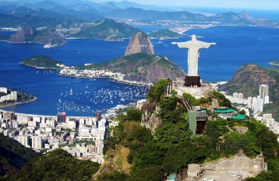 Urban growth
* Urban change
* Urban sustainability

**Section B: The changing economic world**

* Development and quality of life
* Reducing the development gap
* UK economy

**Preparation for Y11 mock 2 exams February-March 2025**

**Name: …………………………………………………………………….**

**Section A: Urban Issues and Challenges**

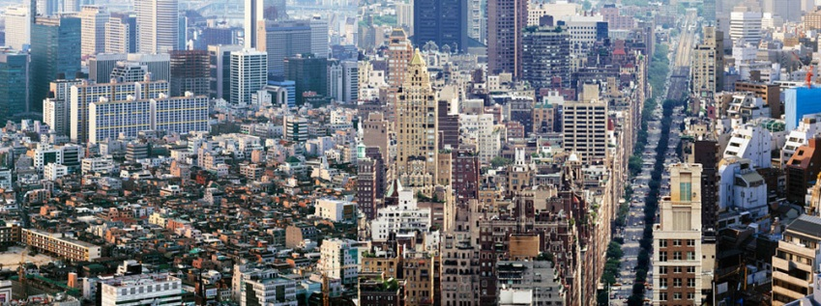A growing proportion of the world’s population live in urban areas. Urban areas are towns or cities. Many people are moving to megacities. These are cities in the world with a population over 10 million people. Many of the world’s fastest-growing cities are currently in Africa, driven by high population growth and significant rural-to-urban (moving from countryside to city) migration. In contrast, cities in Europe, North America, and Japan typically exhibit lower growth rates.

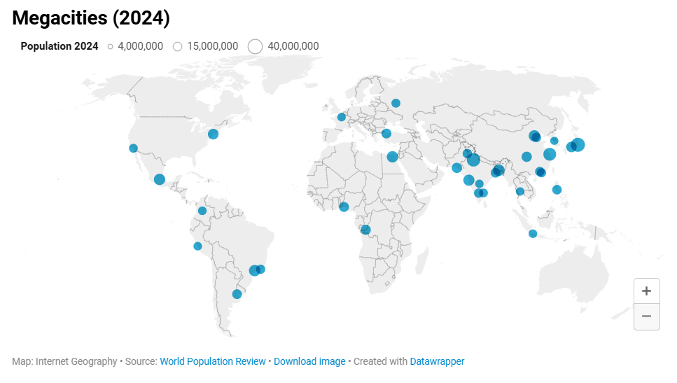

**Urban growth creates opportunities and challenges for cities in LICs and NEEs**

CASE STUDY: A major city in a NEE: Rio de Janeiro, Brazil

1. Rio has grown rapidly in the last 50 years and become a major industrial, administrative, commercial and tourist centre.
2. Migrants have contributed to the economic development of Rio.
3. Rio hosted the Olympics in 2016 and the Soccer World Cup in 2014.
4. Brazil exports sugar and coffee.
5. Brazil is located in the continent of South America.
6. The capital of Brazil is Brasilia since 1960.
7. There are a number of attractions including Christ Redeemer (which is one of the Seven Wonders of the World), Copacabana Beach and Sugar Loaf Mountain.
8. Major TNCs (transnational corporations) e.g. Petrobras have their headquarters located in Rio.

**What are the challenges created by urban growth in Rio de Janeiro?**

|  |  |
| --- | --- |
| **Challenge:** | **Explanation** |
| **Economic** | **Unemployment**  Brazil’s economy was hit by a deep recession in 2015. This has increased unemployment. People have protested about high taxes, poor education and inadequate health care.  The richest 1 per cent of the population earns 12 per cent of the total income. But the income of the poorest 50 per cent is only 13 per cent of the total.  **Informal economy**  Unemployment in the favelas is over 20 per cent. Most work in the informal economy, making a living however they can. People work as street vendors, drivers, labourers. Work in the informal sector is poorly paid (less than £60 per month).  About one-third of Rio’s 3.5 million workers don’t have a formal employment contract, and many are without any insurance cover or unemployment benefit. They do not pay any taxes and the government receives no income from them. |
| **Social** | **Healthcare**  In 2013, only 55 per cent of the city had a local family health clinic. Services for pregnant women and the elderly were very poor, especially in the West Zone.  **Education**  Education in Brazil is compulsory for children aged 6-14. In Rio only half of all children continue their education beyond the age of 14. Many drop out of school and some get involved in drug trafficking. |
| **Environmental** | **Traffic**  Air pollution causes 5,000 deaths per year in Rio.  Heavy traffic that creates a build-up of fumes.  Mist from the Atlantic Ocean mixes with vehicle exhaust fumes and pollutants from factory chimneys.  **Water pollution**  Guanabara Bay is highly polluted causing a threat to major wildlife.  Large amounts of sewage pours into the bay.  Commercial fishing has declined by 90% in the last 20. |

Explain which is the greatest challenge (social, economic or environmental) in Rio

………………………………………………………………………………………………………………………………………………………………………………………………………………………………………………………………………………………………………………………………………………………………………………………………………………………………………………………………………………………………………………………………………………………………………………………………………………………………………………………………………………………………………….

………………………………………………………………………………………………………………………………………………………………………………………………………………………………………………………………………………………………………………………………………………………………………………………………………………………………………………………………………………………………………………………………………………………………………………………………………………………………………………………………………………………………………….

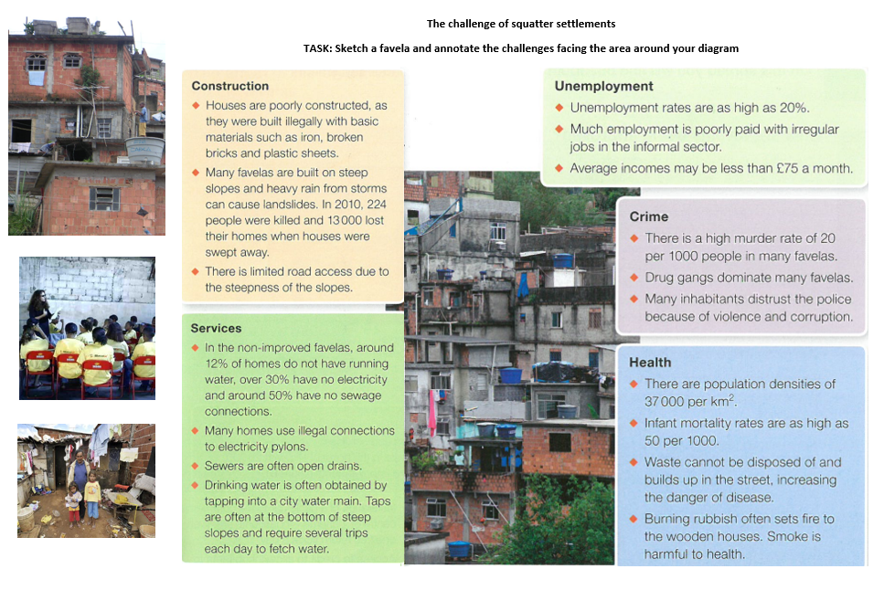

Decide which is the greatest challenge of squatter settlements

………………………………………………………………………………………………………………………………………………………………………………………………………………………………………………………………………………………………………………………………………………………………………………………………………………………………………………………………………………………………………………………………………………………………………………………………………………………………………………………………………………………………………….……………………………………………………………………………………………………………………………………………………………………………………………………………………………………………………………………………………………………………………………………………………

**Urban change in cities in the UK leads to a variety of social, economic and environmental opportunities and challenges**

A case study of a major city in the UK: Sheffield

**Environmental challenges created by urban growth in Sheffield**

* As the population of Sheffield increased urban sprawl (outward growth of the city) has extended particularly to the north, east and south east of the city to include places like Wincobank, Gleadless Valley and Shiregreen. Sheffield established a green belt in 1938. “The aim of the green belt is to prevent the encroachment of urban areas into the countryside and there are only certain types of development that are considered to be appropriate." As the population continued to rise more people relocated to commuter settlements (a planned settlement built to accommodate people from over-crowded inner cities) beyond the green belt on the rural-urban fringe (boundary between a town or city and the countryside), causing population and housing prices to increase. These settlements are experiencing rapid growth as new housing estates and business parks encroach upon the surrounding countryside, reducing green spaces and causing cities to expand.

**Urban sustainability requires management of resources and transport**

Urban sustainability means meeting the needs of the present urban population whilst protecting the cultural heritage, social community and improving the environment through the efficient use of resources and recycling. Land use has changed from secondary industrial brownfield sites to tertiary shops, offices and leisure facilities. This is sustainable because it improves the environment (improved appearance), creates jobs which is good for the economy and provides leisure activities which is good socially.

**Curitiba – an example of a sustainable city**

Curitiba is city in the SE of Brazil, in the state of Parana with a population of approximately 1.75 million people. It has a planned transport system, which is used by 85% of the population.

**Green spaces**

They have solved the flooding problem by turning flood banks into green space. Trees are planted and disused factories were turned into sports facilities. Flood waters can go into the lakes which means it is diverted from city. High-rise developers could either pay cash to build more storeys or provide green spaces.

**Transport**

There are dedicated bus lanes and bi-articulated buses, which can carry large numbers of people. Passengers pre-pay (no time to wait for people to pay) and there are extra wide bus doors so they load/unload quickly.

As a result, there is a lack of traffic congestion in rush hour. The system is 500 times cheaper than building a subway, and the same number of people can travel as in Rio de Janeiro, but without the cost of the system. Curitiba has the lowest rate of air pollution in Brazil. It has cut travel times by 1/3 and most commuters take the bus.

**Section B: The Changing Economic World**

**Development refers to a process that raises the standard of living within a country**.

**Consequences of uneven development**

* Uneven development creates differences between countries. Higher income countries (HICs) have a lot of money and so they have the power to make decisions that affect lower income countries (LICs).
* Many LICs have a shortage of safe, clean water and have low levels of health. They do not have factories or processing facilities and so they have to sell materials in their raw form. Raw materials usually sell for much less money than finished products and so these countries earn less. Some governments in LICs are corrupt. This means that money earned is not necessarily used to benefit the people that need it and disparities in wealth and health occur. Some LICs also have high levels of international migration, as people move to find work and a better standard of living. This results in fewer people of a working age and an increased proportion of dependent people.

**Various strategies exist for reducing the global development gap**

**Managing differences in development**

The development gap is the difference in levels of development between the richest and poorest countries in the world. Many believe that the gap between the high-income countries (HICs) and low-income countries (LICs) is getting wider. Reducing the development gap would lead to an increase in the quality of life for millions of people around the world.

There are lots of ways that can help to reduce the development gap.

|  |  |
| --- | --- |
| Investment | Large companies can locate part of their business in other countries. This helps a country to develop as the companies build factories, lay roads and install internet cables. |
| Aid | Aid is usually in the form of financial assistance offered by countries, organisations, and TNCs. Long-term aid supports development projects such as improving sanitation, water supply and education. Short-term aid is often given in response to natural disasters. |
| Using intermediate technology | Intermediate technology is using equipment and techniques that are suitable for their country of use. Many poorer countries do not have the skills to maintain expensive equipment. Small-scale, basic solutions are usually more appropriate. |
| Fairtrade | Fairtrade is paying producers a reasonable price for the goods that they produce. Many farmers in LICs are paid very low wages. This means that they cannot escape poverty. Fairtrade gives farmers a better chance in life. |
| Debt relief | Many LICs owe money to other countries. Often the repayments and interest are so expensive that indebted countries have no money left to spend on development projects. Debt relief is when debts are either reorganised to make them more manageable, or reduced. |
| Microfinance loans | Microfinance loans are when money is lent to LICs to help them to develop. These are often small loans with reasonable interest rates. They are available to people and businesses who may normally struggle to get credit. |

**Some LICs and NEEs are experiencing rapid economic development which leads to significant social, environmental and cultural change**

A case study of a NEE: India, Asia

**India: political, social, cultural and environmental context**

Political – India was a British colony until 1947, but now it has a democratically elected government

Social – India has a medium level of development. There are large inequalities in the country. Education is improving but adult literacy rate is still 75%.

Cultural – India has rich and diverse culture. It has 22 official languages and is famous for its production of ‘Bollywood’ films.

Environmental – it has a varied landscape e.g. Himalayas in the north, Thar Desert in the north west, and large areas of forest.

**India’s trading role with its neighbours and the wider world is changing:**

India is playing a larger role in regional and global politics. India is increasingly important globally – it exports services (IT support) and manufactured goods (e.g. medicines) across the world and it’s a member of the World Trade Organisation and the G20 (a group of 20 of the world’s biggest economies). International trade is growing due to:

1. India is reducing barriers to trade and encouraging foreign direct investment.

2. Trade with foreign businesses, particularly those who get companies in India’s large service sector to do office jobs for them, is also increasing.

3. India is also working with its neighbours to build the TAPI pipeline to carry natural gas from Turkmenistan, through Afghanistan and Pakistan to India.

**CASE STUDY: Rural (countryside) landscapes in the UK are changing**

Rural landscapes are changing in the UK; some areas are experiencing rapid population growth as people are moving out into the countryside for a more peaceful life, whereas other areas are experiencing population decline. For example, However, some remote rural areas in the UK are experiencing population decline, for example the Outer Hebrides.

Rural landscapes in the UK are experiencing significant change. Although the majority of people live in urban environments, 19% of the population live in rural areas. Despite rural areas not appearing crowded, the population in most rural areas is growing due to counter-urbanisation. People are migrating from urban to rural areas for a better quality of life.

### **What is the impact of increasing population in rural areas?**

**South Derbyshire** one of the areas experiencing a rapid population growth of 15.9% since 2001 and this is projected to increase further 27% by 2033. The Toyota manufacturing plant is a pull factor. Average earnings are around £28,493 per year.

**Benefits of population growth in rural areas**

* An increased population leads to a higher demand for goods and services. This helps ensure the future of rural shops, schools and businesses.
* It provides balance to rural-urban migration, particularly as young people move away in search for better opportunities.
* New people are more likely to invest in new, local businesses.
* New developments in rural areas provide jobs.

**Problems of population growth in urban areas**

* Rural areas can lose shops as commuters buy products in supermarkets in urban areas on their way home from work. Many workers commute to places like Derby.
* The increase in ‘outsiders’ can change the social fabric and rural culture.
* Older people tend to move to rural areas, which raises the average age.
* House prices often increase rapidly due to wealthy newcomers, pushing out local people.
* Car owning commuters do not require public transport, so services may be reduced, affecting local people.
* Resentment may be felt towards new members of the rural community.
* Modern developments in rural areas cause tensions with the local community.
* The sale of agricultural land in rural areas can lead to unemployment in the local community.

**What is the impact of declining populations?**

The **Outer Hebrides** are a group of islands off the northwest coast of Scotland. Since 1901 it has experienced a 50 per cent decline in its population, mainly due to young people moving away. They have migrated to the mainland in search of jobs. The current community is around 27,000, and most inhabitants live on the islands of Lewis. Average earnings are around £15,000 per year.

Social impacts:

* School closures could result from fewer children
* An ageing population, caused by the migration of young people, will require higher amounts of social care, which will have social and economic impacts
* A further decline in the fishing and farming industry due to the ageing population

Economic impacts:

* Maintaining transport services such as ferries and other services is very costly
* There has been a significant decline in traditional fishing for lobsters and prawns
* Tourism has become an essential source of income. However, the infrastructure is struggling to cope with this
* Shellfish catches have increased, due to more foreign boats

**What are the social and economic impacts of a growing population and a declining population?**

Use the information to complete the table by adding 2-3 impacts in each box.

|  |  |  |
| --- | --- | --- |
| **Give 2-3 facts about the population** | **Social effects (positive and negative)** | **Economic effects (positive and negative)** |
| **Growing population**  **(South Derbyshire)** |  |  |
| **Declining population (Outer Hebrides)** |  |  |

Which area is experiencing the most positive impacts? Why?

…………………………………………………………………………………………………………………………………………………………………………………………………………………………………………………………………………………………………………………………………………………………………………………………………………………………………………………………………………………………………………………………………………………………………………………………………………………………………………………………………………………………………………………………………………………………………………

Which area is experiencing the most negative impacts? Why?

…………………………………………………………………………………………………………………………………………………………………………………………………………………………………………………………………………………………………………………………………………………………………………………………………………………………………………………………………………………………………………………………………………………………………………………………………………………………………………………………………………………………………………………………………………………………………………