**Y11 Supporting Success: Art**

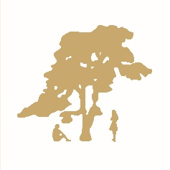

**Course Title: GCSE Art and Design: Fine Art**

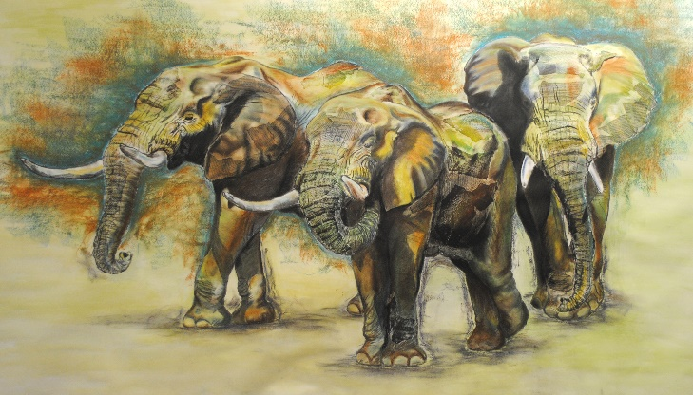**COURSE CONTENT**

Students will be assessed on 2 components a **Portfolio** and an **Externally set task**.

**Component 01: Portfolio**

The **Portfolio** is a body of practical work developed from a theme and resulting in a final piece. Themes for the portfolio are individual and chosen through discussion with your Art teacher. All selected work produced for the component, including the research, planning and development work produced in the preparatory period must be submitted for assessment.

**Component 02: Externally set task**

The **Externally set task** is issued on 2 January in Year 11 and will give students a choice of five themes, each with a choice of visual starting points or stimuli. From this paper, students are expected to choose one option. Students will be given a preparatory period during which they will research, plan and develop ideas for their own response to the option they have chosen. They will then produce a final outcome within a 10-hour supervised time period. All selected work produced for the component, including the research, planning and development work produced in the preparatory period must be submitted for assessment.

**ASSESSMENT:**

**A Portfolio, which is 60% of the total GCSE**

**An externally set task, which is 40% of the total GCSE**

Both components are marked internally by your teacher and moderated externally by OCR.

**KEY DATES:**

**Y11 Art Mock exam**—**Thursday 14 November.** Students will work on individual pieces of practical artwork in timed conditions. These pieces will be planned with students in lessons prior to the exam. The exam will be held in exam conditions with invigilators. Students will get their normal breaks during the day. The mock exam cannot recreate the final 10 hour exam, however it allows students to practise completing artwork at pace in timed conditions.

**Y11 Portfolio deadline – Friday 20 December 2024**

**Y11 Externally set task** **paper issued to students** – **Monday 6 January 2024** It is important students start their preparation work quickly and keep up to date with it as this is marked alongside the exam piece and is worth 75% of the exam mark.

**Y11 Art exam – Tuesday 1 April, Wednesday 2 April, Thursday 3 April 2025**

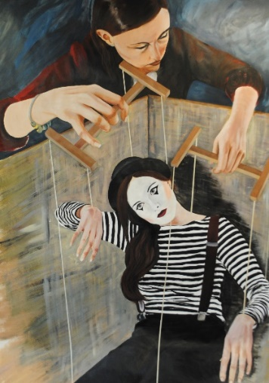**How can you support your child?**

* Check they are producing 2 hours of independent work outside of lessons each week
* Encourage your child to attend the Curriculum + sessions run by their art teacher
* The best way for students to improve their grades in Art is to attend the extra-curricular sessions offered at breaks and after school. Students have access to a suitable place to produce artwork, art materials and additional advice and support from their art teacher.
* We also loan art materials for students to work at home.